Euler’s Formula
Here is a planar graph:
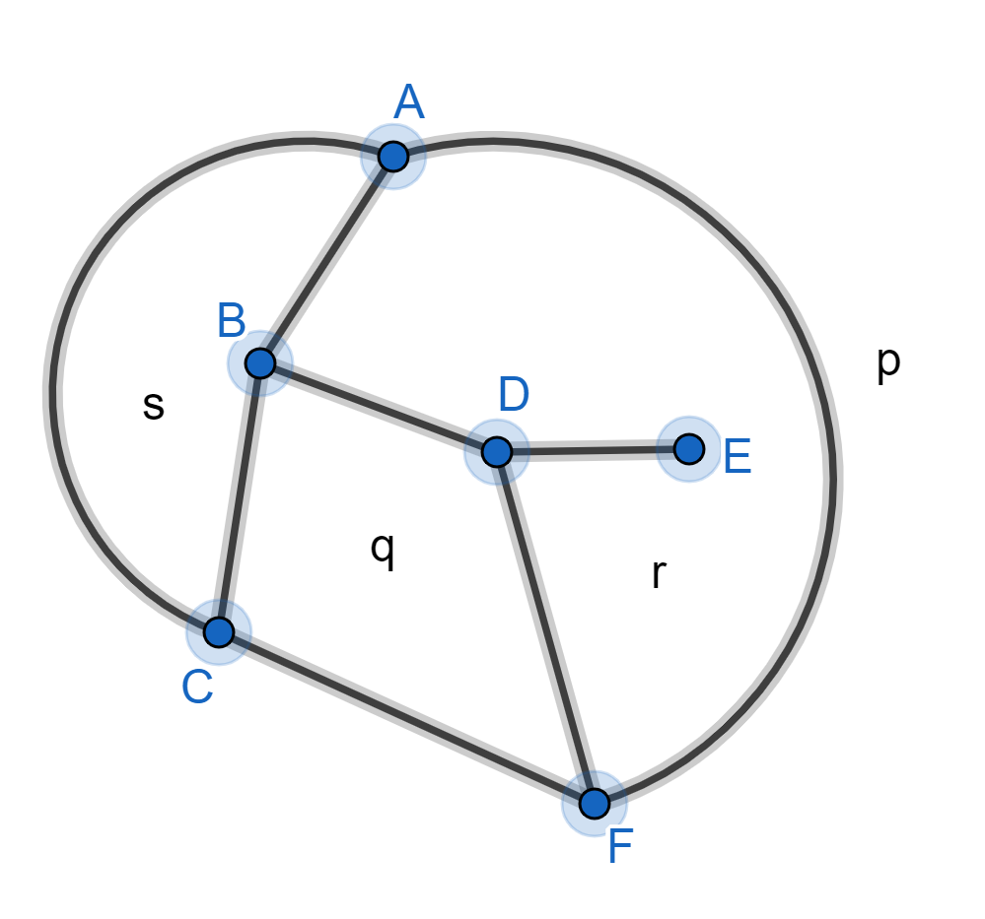

It is planar because no two edges cross-over each other.
The graph divides the plane into regions(called faces).

Euler’s formula for planar graphs
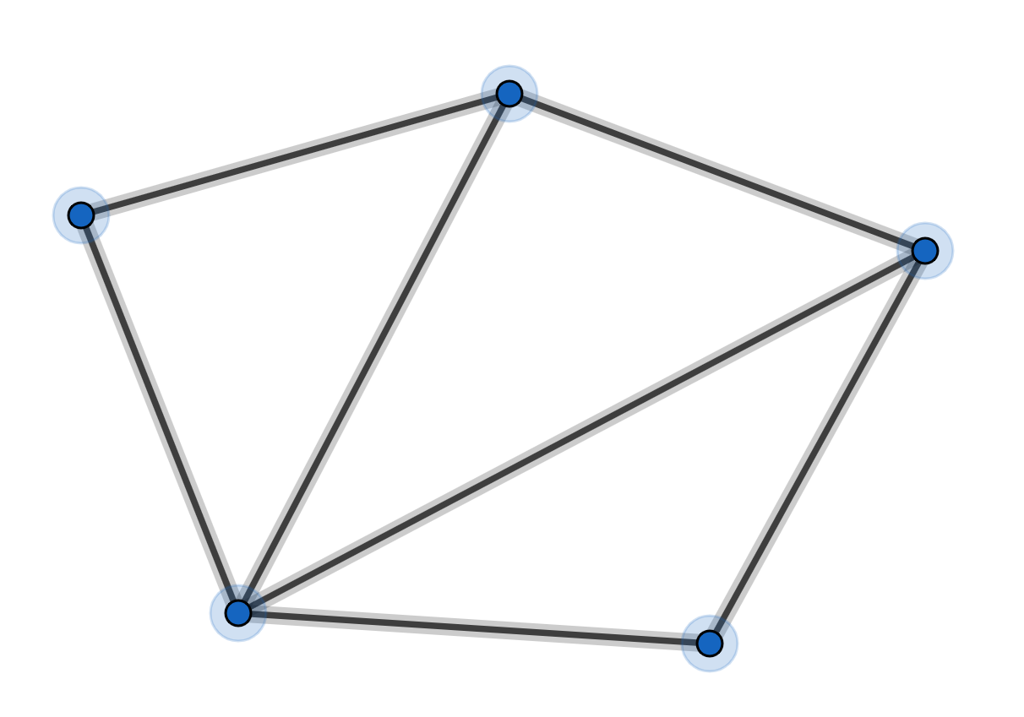

For this planar graph:
the number of vertices is:
the number of edges is:
the number of faces is: (remember to include the outer face)

Euler’s formula:
For any planar graph
Proof
Start with the graph above.
You can rub-out an edge soandandstays unchanged.

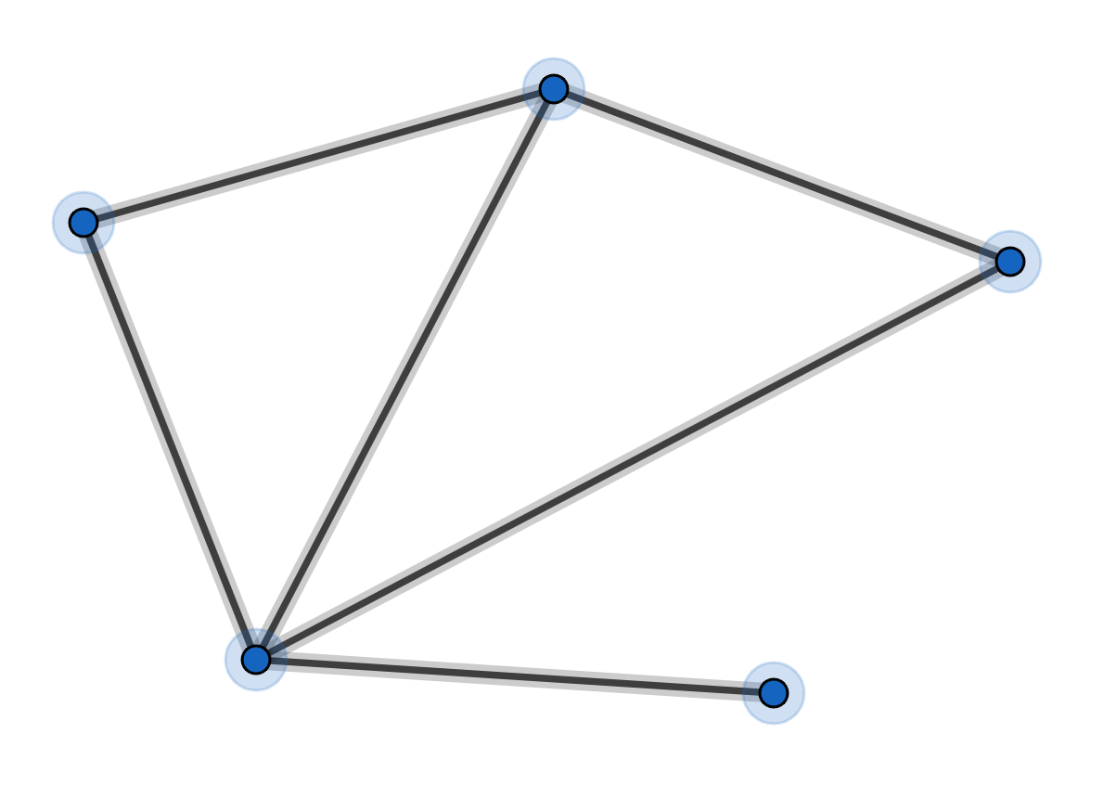

You can rub-out an edge soandand stays unchanged.
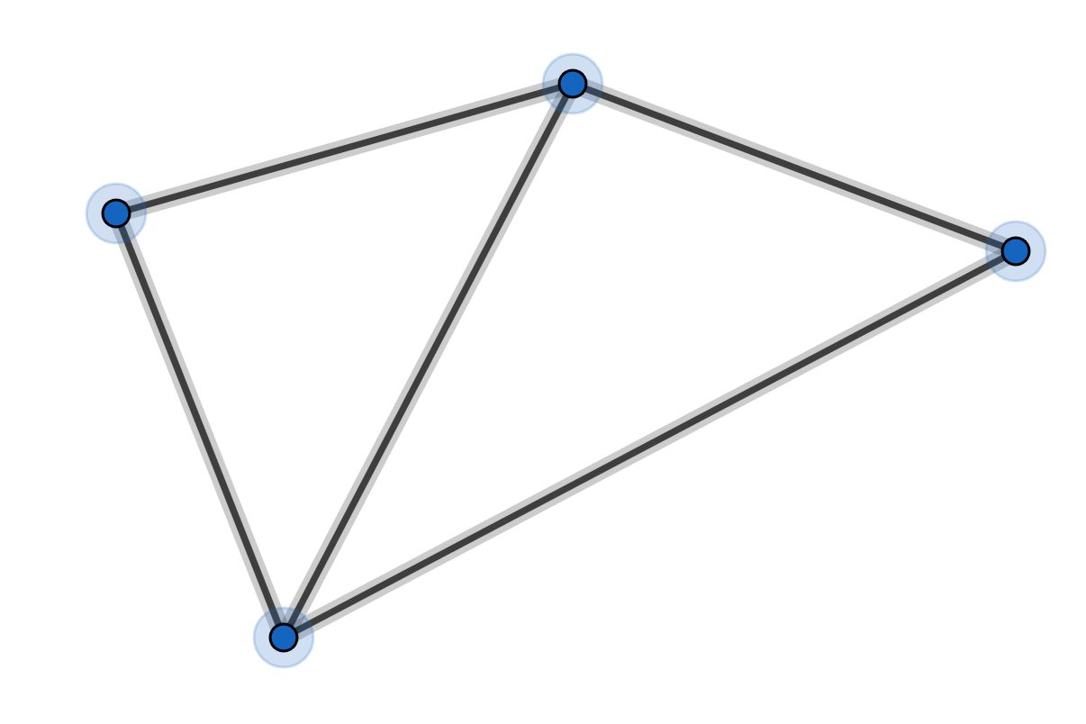

Once all the rubbing-out has been done, you will be left with:
one faceone vertexno edgesand
But all the rubbing-out leavesunchanged.
Sofor the original graph.

EXAMPLE
We can redraw this graph:

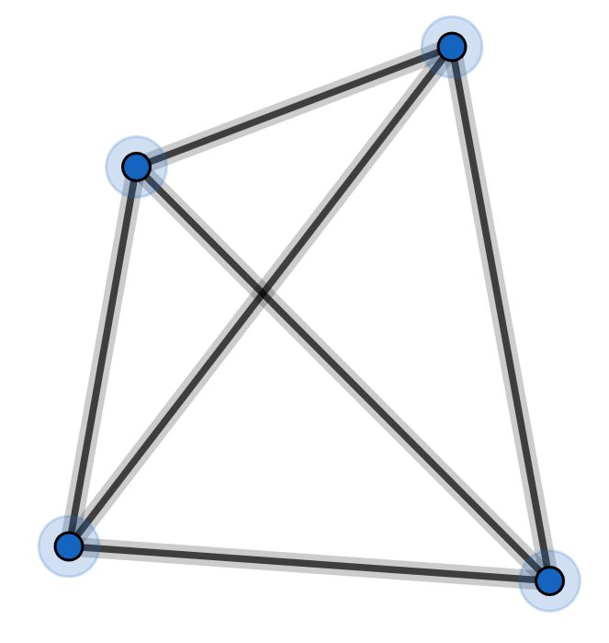

so that it is planar:

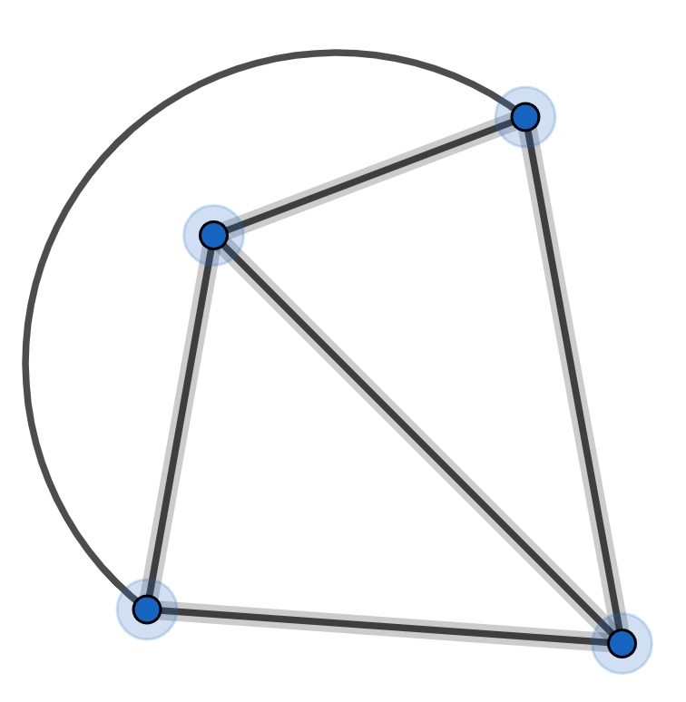

Theorem
We cannot redraw this graph so that it is planar:

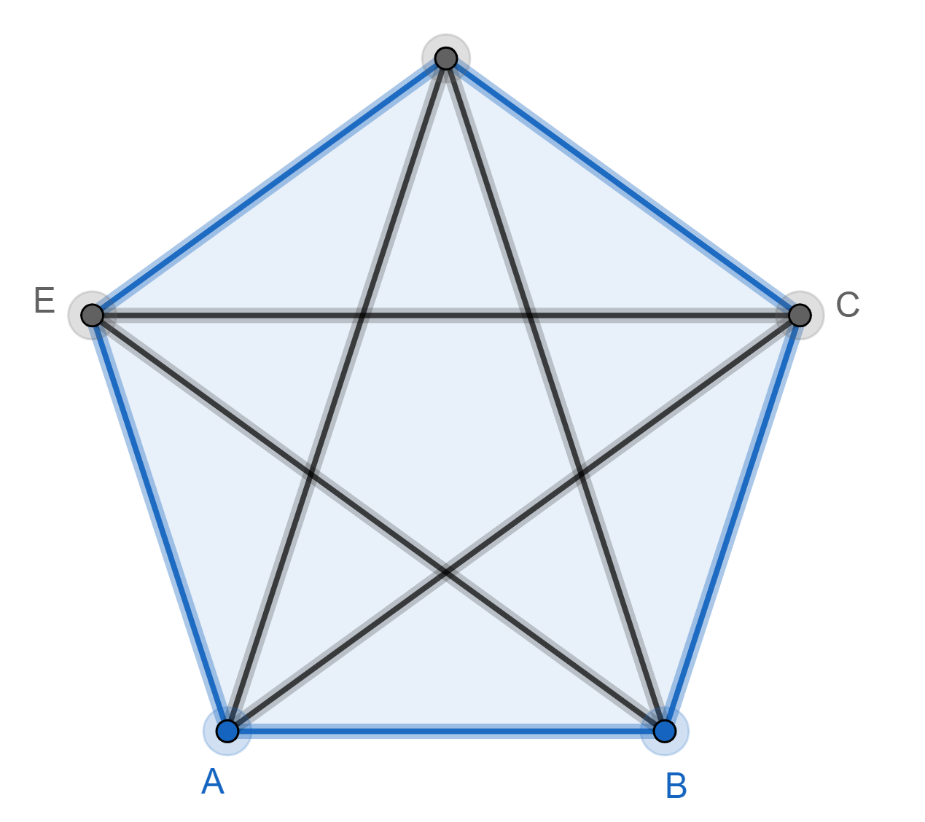

Proof (by contradiction)
Assume we can redraw this graph so that it is planar.

Each vertex is joined to 4 edges.
So:
No!
Each edge is shared with 2 vertices.
So:

So by Euler’s formula
Each face has at least 3 edges.
So:
No!
Each edge is shared by 2 faces.
So:

So:

Contradiction.

Theorem
We cannot redraw this graph so that it is planar:
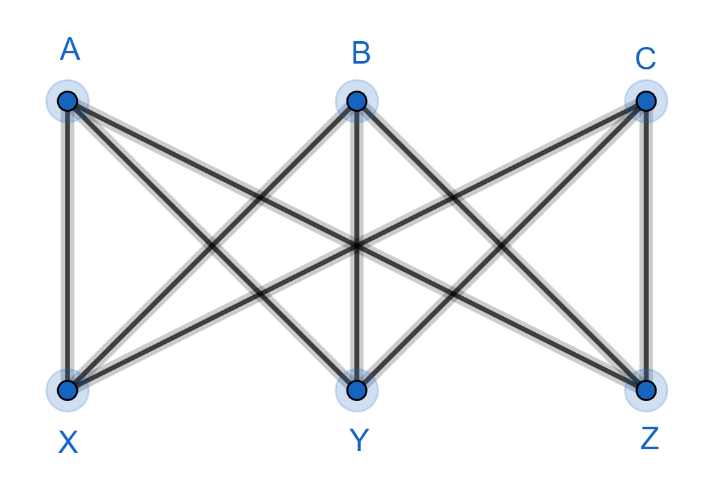

Proof (by contradiction)
Assume we can redraw this graph so that it is planar.
and so by Euler’s formula
A face cannot have just 3 edges – try drawing one!
Each face has at least 4 edges.
So:
No!
Each edge is shared by 2 faces.
So:

So:
Contradiction.
This is known as the utilities problem. Imagine A, B, C are houses and X, Y, Z are gas, water, electricity supply points. Each house needs to be connected, by pipe, to each utility. Can we do this without any pipes crossing over each-other? No!

